STP and Etherchannel Configuration :
In this lab I successfully configured a network topology of three switches I implemented Etherchannel between SW1 and SW2
And i verified the Spanning Tree protocol (STP) to prevent the loop
SW1 act as the root bridge .


Etherchannel SW1 show
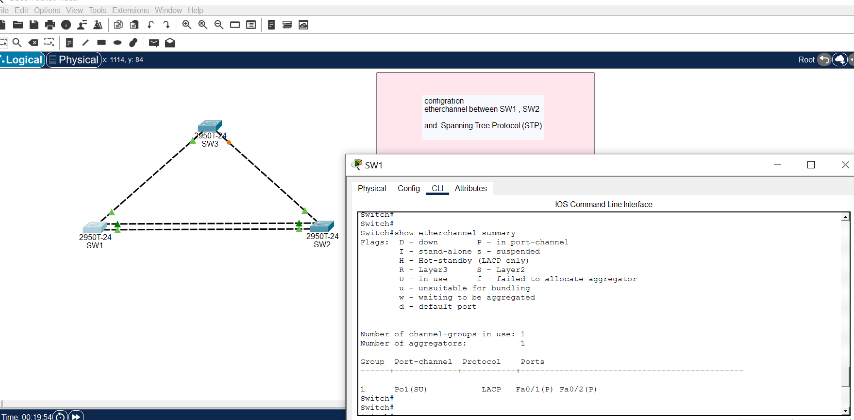


Spanning-tree protocol SW1
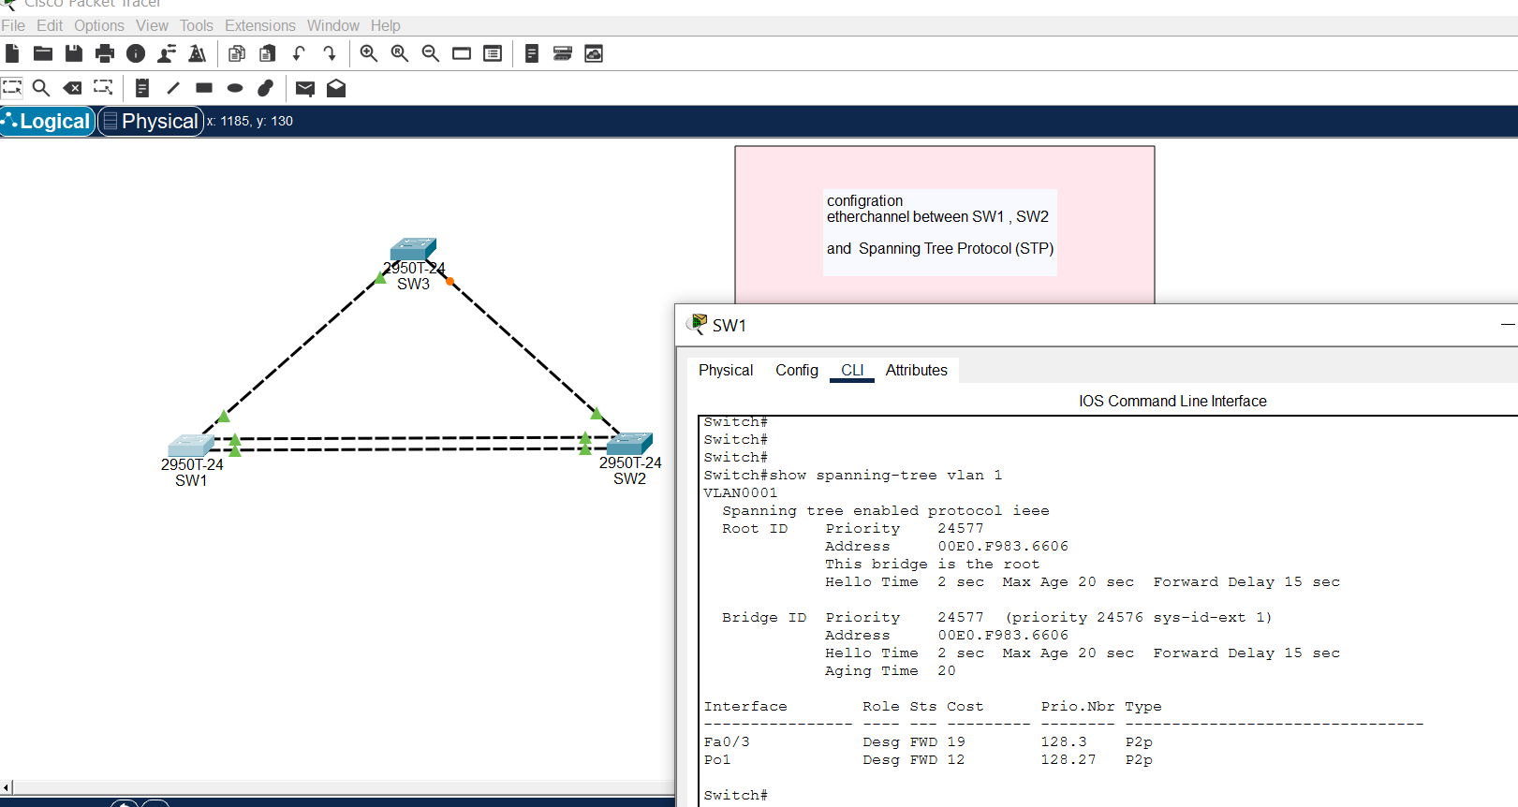


Spanning-tree protocol SW2
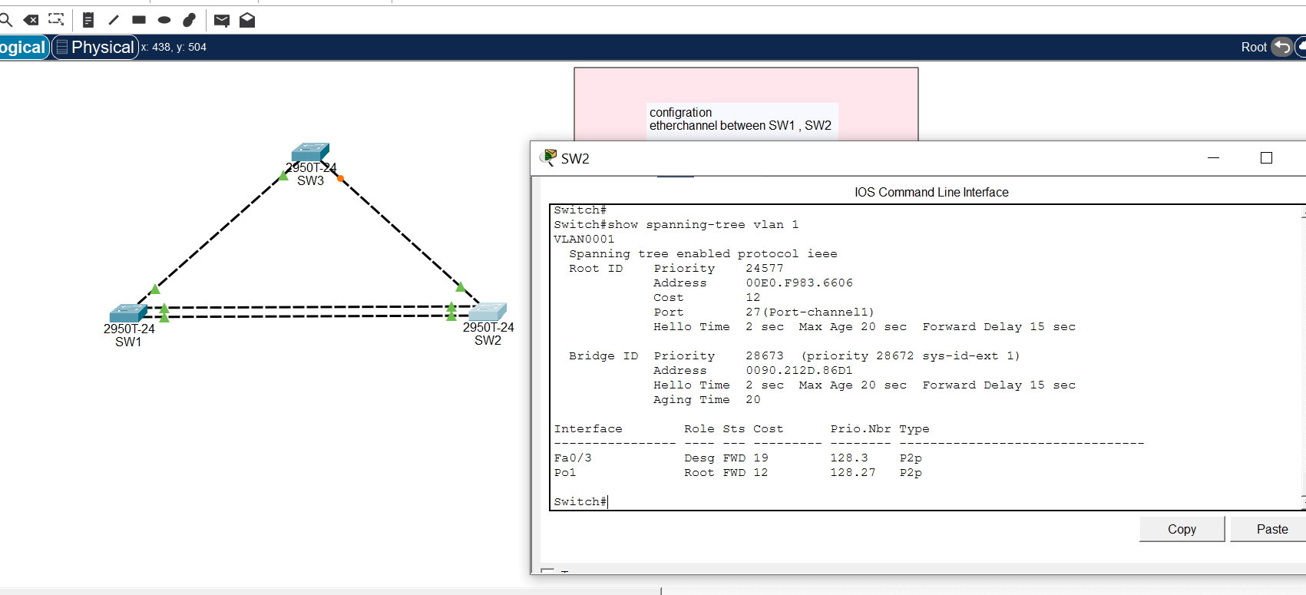


Spanning-tree protocol SW3
